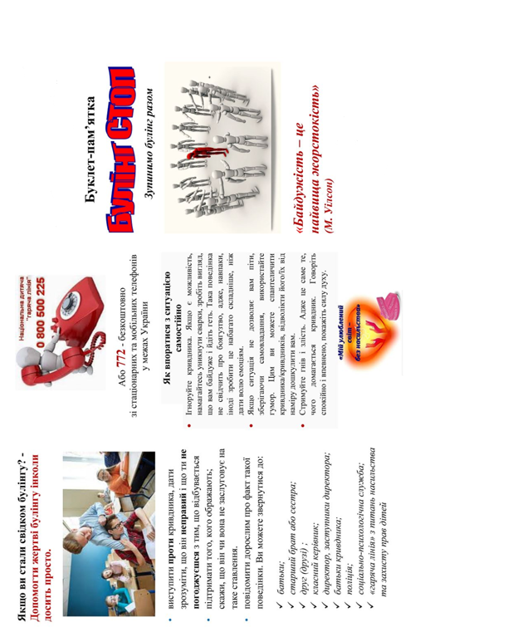

[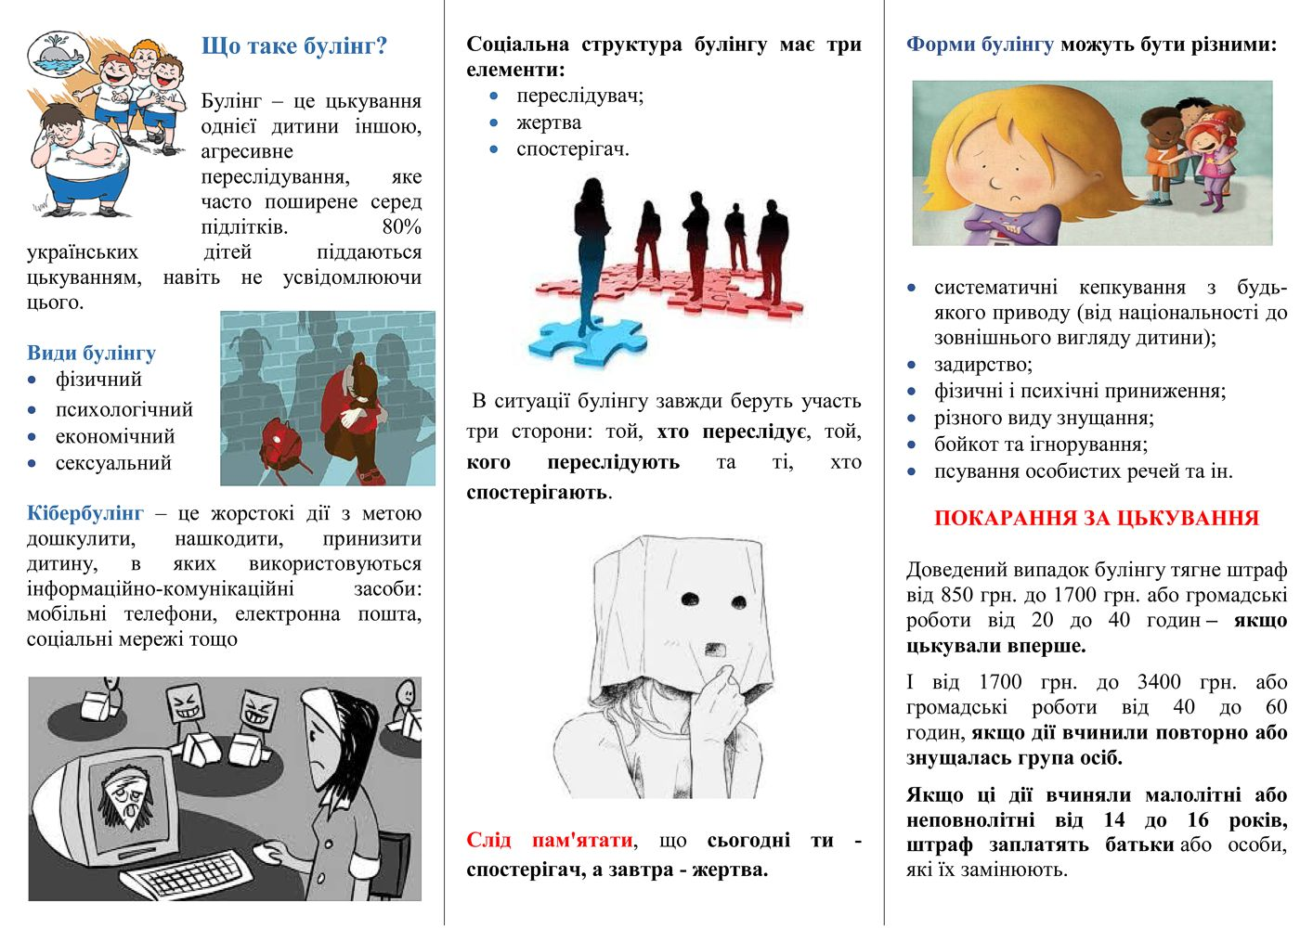](http://vpu40.ptu.org.ua/wp-content/uploads/2019/01/%D0%91%D1%83%D0%BB%D1%96%D0%BD%D0%B3-%D0%A1%D0%A2%D0%9E%D0%9F_%D0%B1%D1%83%D0%BA%D0%BB%D0%B5%D1%82_-2.jpg)